Example:

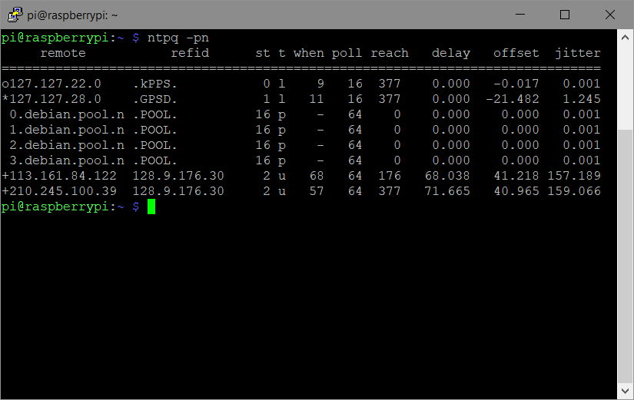

Columns define:

**remote**: Peers specified in the *ntp.conf* file

*: Current time source

#: Source selected, distance exceed maximum value

o: Source selected, Pulse Per Second (PPS) used

+: Source selected, include final set

x: Source false ticker

.: Source selected from end of candidate list

-: Source discarded by cluster algorithm

Blank: source discarded high stratum, failed sanity

**refid**: remote source’s synchronization source

IP address- The IP address of the remote peer or server.

.ACST.- NTP manycast server.

.ACTS.- Automated Computer Time Service clock reference from the American National Institute of Standards and Technology.

.AUTH.- Authentication error.

.AUTO.- Autokey sequence error.

.BCST.- NTP broadcast server.

.CHU.- Shortwave radio receiver from station CHU operating out of Ottawa, Ontario, Canada.

.CRYPT.- Autokey protocol error

.DCFx.- LF radio receiver from station DCF77 operating out of Mainflingen, Germany.

.DENY.- Access denied by server.

.GAL.- European Galileo satellite receiver.

.GOES.- American Geostationary Operational Environmental Satellite receiver.

.GPS.- American Global Positioning System receiver.

.HBG.- LF radio receiver from station HBG operating out of Prangins, Switzerland.

.INIT.- Peer association initialized.

.IRIG.- Inter Range Instrumentation Group time code.

.JJY.- LF radio receiver from station JJY operating out of Mount Otakadoya, near Fukushima, and also on Mount Hagane, located on Kyushu Island, Japan.

.LFx.- Generic LF radio receiver.

.LOCL.- The local clock on the host.

.LORC.- LF radio receiver from Long Range Navigation (LORAN-C) radio beacons.

.MCST.- NTP multicast server.

.MSF.- National clock reference from Anthorn Radio Station near Anthorn, Cumbria.

.NIST.- American National Institute of Standards and Technology clock reference.

.PPS.- Pulse per second clock discipline.

.PTB.- Physikalisch-Technische Bundesanstalt clock reference operating out of Brunswick and Berlin, Germany.

.RATE.- NTP polling rate exceeded.

.STEP.- NTP step time change. The offset is less than 1000 millisecends but more than 125 milliseconds.

.TDF.- LF radio receiver from station TéléDiffusion de France operating out of Allouis, France.

.TIME.- NTP association timeout.

.USNO.- United States Naval Observatory clock reference.

.WWV.- HF radio receiver from station WWV operating out of Fort Collins, Colorado, United States.

.WWVB.- LF radio receiver from station WWVB operating out of Fort Collins, Colorado, United States.

.WWVH.- HF radio receiver from station WWVH operating out of Kekaha, on the island of Kauai in the state of Hawaii, United States.

**st**: stratum level of the source

**t**: types available

l: local (such as GPS, WWVB)

u: unicast (most common)

m: multicast

b: broadcast

-: netaddr

**when**: number of seconds passed since last response

**poll**: polling interval, in seconds, for source

**reach**: indicates success/failure to reach source, 377 all attempts successful

**delay**: indicates the roundtrip time, in milliseconds, to receive a reply

**offset**: indicates the time difference, in milliseconds, between the client server and source

**disp/jitter**: indicates the difference, in milliseconds, between two samples

Reference:

Aaron Toponce: Real Life NTP - <https://pthree.org/2013/11/05/real-life-ntp/>

NTP: ntpq output explained - <http://tech.kulish.com/2007/10/30/ntp-ntpq-output-explained/>